
Figure X: researcher inspecting the cabin of a commercial truck at Hino Parañaque Subic GS Auto Inc. (SGSA). Figure X: Further inspection of the sample vehicle at the partner company's facility.

Figure X: Researchers and the partner company’s representative evaluating the cloud dashboard during prototype demonstration.


Figure X: A demonstration session of the prototype's web-based monitoring interface.

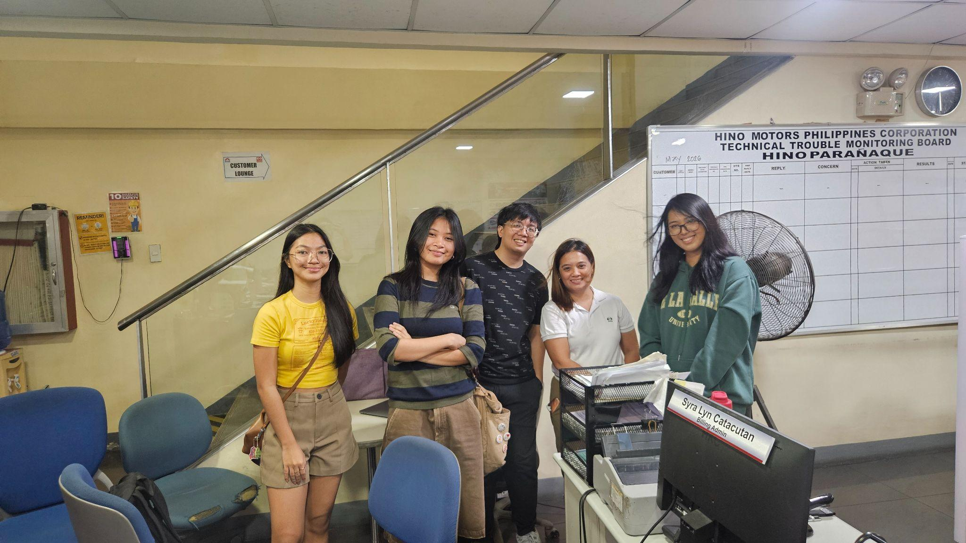
Figure X: The research proponents at the Hino Parañaque office following a successful meeting and demonstration of the prototype system with the partner company.


Figure X: The research team during the initial consultation meeting with the representative from Hino Parañaque Subic GS Auto Inc. (SGSA).


Figure X: A group photograph of the research team and the partner company's representative in the conference room.

Survey:

Rate your level of agreement with each statement (1 = Strongly Disagree, 5 = Strongly Agree).

Section A: Dashboard & Real-Time Monitoring
1. The dashboard clearly shows where each truck is located at any given time.
2. The fuel level displayed on the dashboard is easy to read and understand.
3. The information shown on the dashboard updates quickly and feels current.
4. I can easily see the route history and path a truck has taken.
5. The dashboard makes it easy to monitor multiple trucks at the same time.
6. The map view on the dashboard is easy to navigate and understand.
7. The GPS location shown on the map accurately reflects where the truck is at any given time.
Section B: Fuel Monitoring Accuracy
1. The fuel level shown in the system matches what I would expect based on operations.
2. The system provides fuel consumption information that is useful for day-to-day management.
3. Fuel data is consistently available even when a truck is in areas with poor signal.

Section C: Anomaly Detection & Alerts
1. The system alerts me when there is an unusual or suspicious drop in fuel.
2. The anomaly alerts are easy to understand — I know what they mean right away.
3. The system does not generate too many false alarms or alerts that turn out to be nothing.
4. When an anomaly is flagged, it provides enough context (e.g., time, location, truck) for me to investigate.
5. The anomaly detection helps me identify possible fuel theft or leakage more effectively.

Section D: Driver Safety & Rest Alerts
1. The system notifies me when a driver has been on the road for too long without a break.
2. The rest and driving hour alerts help me ensure the safety of our drivers.
3. I can easily see the history of driver alerts and rest compliance from the dashboard.
4. The system's overspeed alerts are helpful in keeping drivers within safe speed limits.

Section E: Maintenance Monitoring
1. The system accurately tracks the distance traveled by each truck.
2. I am notified in time when a truck is due for an oil change or maintenance check.
3. The maintenance alerts have helped reduce unexpected vehicle breakdowns.
4. I can view the maintenance history of each truck through the dashboard.

Section F: Overall System Usability & Satisfaction
1. The system is easy to learn and use without needing a lot of technicality.
2. The system has helped improve how we manage our fleet overall.
3. I would recommend this system to other fleet operators or transport companies.
4. The system has reduced the time I spend manually checking on trucks and drivers.
5. Overall, I am satisfied with the system's performance and usefulness.

Feedbacks
1. What feature of the system do you find most useful? *
- Real-time GPS tracking
- Fuel monitoring
- Anomaly alerts
- Maintenance alerts
- Driver safety alerts

2. Any issues or difficulties you experienced while using the system? *
- No issues
- Slow updates
- Inaccurate data
- Interface complexity
- Connectivity issues

3. How has the system changed your team's monitoring of fuel and truck operations compared to before?
- Declined
- Slightly Declined
- No change
- Slightly Improved
- Significantly improved

4. How much has the system improved driver safety monitoring?
- Declined
- Slightly Declined
- No change
- Slightly Improved
- Significantly improved

